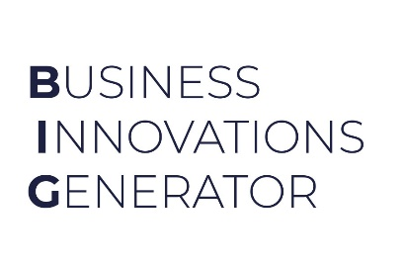
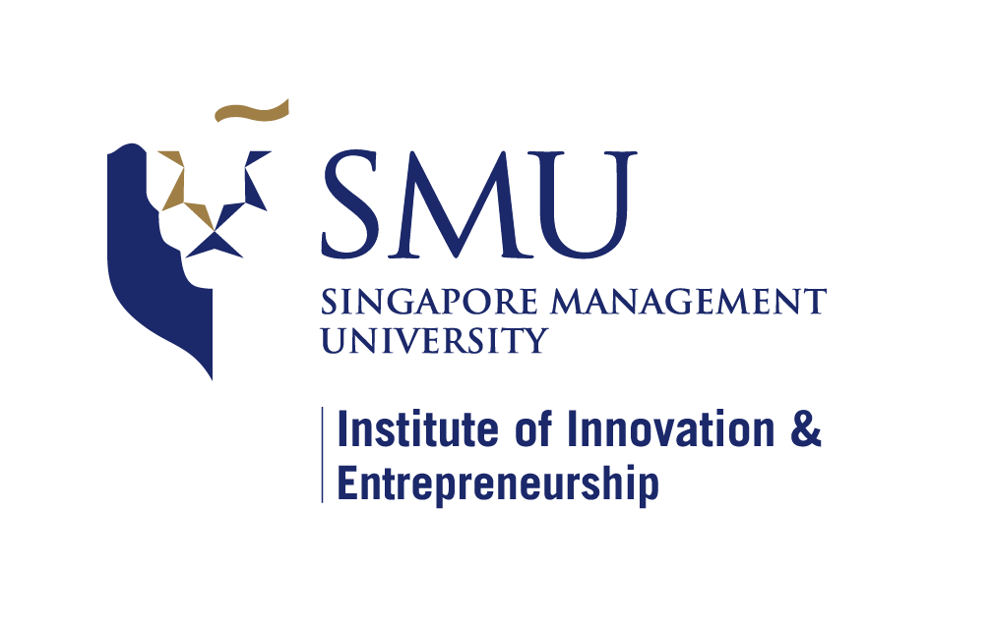
v.1.0
MIlestone setting DOcument
For BIG Incubation Programme

Milestone Setting Guidelines

As a next step, you are required to set 2 milestones for your start-up.
You may use the following guidelines for the start and completion dates when setting the milestones.

Start By: <incubation kick-off date>
- (Estimated incubation kick-off months are March for the January BIG intake, August for the May BIG intake and November for the September BIG intake)

Complete By: (for all milestones) should be within 6 to 8 months from the incubation kick-off date.

Some suggestions & samples are given below for your ready reference.
Please provide a minimum of:
- 1x product or technological development milestone
- 1x business development (BD) milestone
Samples provided here are for you reference, you may please customize it to meet your requirements and suitable for the start-up.

SAMPLES:
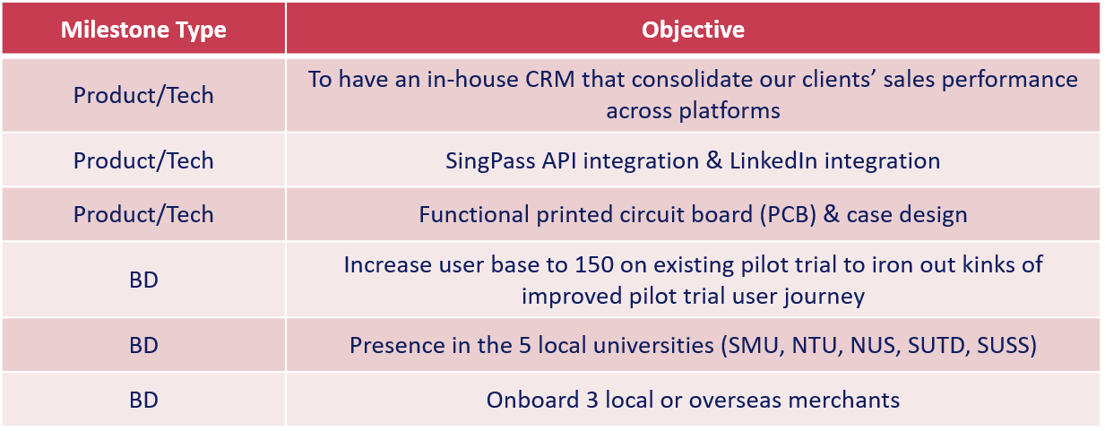
Startup Name | Ambient Systems
Are you a Startup SG Founder [Third party]? | No
Cohort | Jan ‘22

 | <For Startup to Fill>
 | Objective  (Overarching goal) | Action  (what are the steps that you’re planning to take to achieve this?) | Start by:  (DD/MM/YY) | Complete by:  (DD/MM/YY)
Product | Complete MVP UX/UI Designs | Extend the current UX / UI designs | 21/02/2022 | 28/02/2022
Product | Complete MVP Machine Learning Model | Build ML model for IAQ application | 21/02/2022 | 06/03/2022
Product | Complete MVP Full-stack Application | Build a web app based on designs (item 1) with model outputs (item 2) | 21/02/2022 | 21/03/2022
BD / Marketing | Start product trial with an established customer | Find 1 early adopter interested in trying the MVP through a SaaS model  (no POC, POV, JDA, TDA, LOI, MOU, Pilot, revenue sharing, etc.) | 21/02/2022 | 01/04/2022
BD / Marketing | Complete MVP Demo Video | Create a < 1-minute demo video based on the MVP app (item 3) or design (item 1) | 07/03/2022 | 21/03/2022
BD / Marketing | Complete Customer (Sales) Presentation | Prepare a slide deck for customers interested in a trial | 21/02/2022 | 06/03/2022
Fundraising | Pre-seed Round Fundraising ($225k USD) | Send investment deck to personal network  Schedule calls and discussions  Term sheets | 21/02/2022 | 31/03/2022
Fundraising | Apply to ESG Programmes | Identify relevant ESG programmes for tech and market development | 21/02/2022 | 01/04/2022
Tech | Singapore IMDA Certification | Look into relevant IMDA certifications in the areas of data management, analytics, and machine learning | 21/02/2022 | 30/04/2022
Tech | File new IP | Complete patent landscape  Draft invention writeup  Legal review and feedback | 21/02/2022 | 30/04/2022
Tech | Complete NUS IP | Complete AI model for Urban Farm application  Revise patent filing based on the completed model | 01/04/2022 | 30/04/2022

Prepared & Signed by Startup Founders | Approved by IIE Representative (if applicable): | Approved / Endorsed by EiR:
Name & Signature: Ivan Damnjanović  Title: CEO and Founder  Date: Feb 21, 2022 | Name & Signature:  Date: | Name & Signature:  Date:

